Dynamode USB-SOUNDCARD Adapter

7.1 Channel

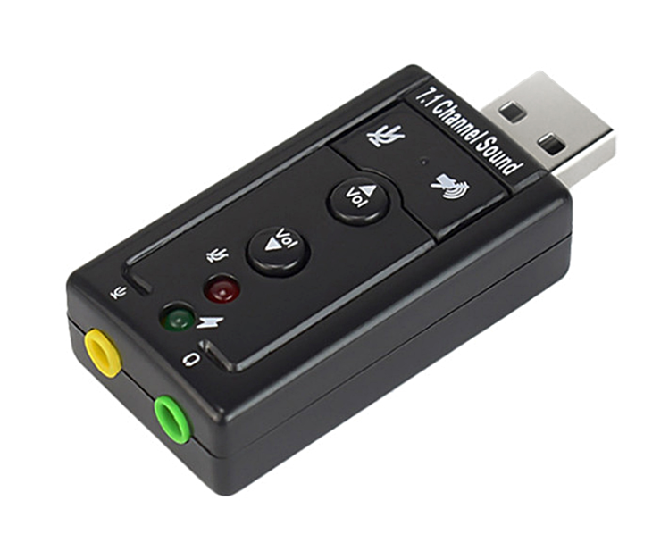

About this item
The USB Virtual 7.1 Channel Sound Adapter is a highly flexible audio interface which can be used either with Desktop or Notebook systems. Bundled with Xear 3D Sound simulation software, it turns your stereo speaker or earphones into 7.1 channel environment. No drivers required, just plug and play for instant audio playback, also compatible with all major Operating systems.

Features & Specification
- Complaint with USB 2.0 Full-Speed(12 Mbps) Specification
- Compliant with USB Audio Device Class Specification 1.0
- Compliant with USB HID Class Specification 1.1
- USB bus-powered mode, no external power required
- Connectors: USB Type-A, Stereo output jack, Mono microphone-input jack
- Functional keys: Microphone-Mute, Speaker-Mute, Volume-Up Volume-Down
- LED indicators: Microphone-Mute Status, Activity
- Include Xear 3D, the virtual 7.1 channel sound simulation software for Windows XP/Vista/Win 7
- Driverless-No driver required for Windows 98SE/ME/2000/XP/Server 2003/ Vista/Win 7, Linux, MacOS

System Requirement
- Desktop or notebook PC with a USB port
- Windows 98SE/ME/2000/XP/Server 2003/Vista/Win 7, Linux, MacOS 10 or higher
- Xear 3D(Virtual 7.1 channel sound simulation sotfware) for Windows XP/Vista/Win 7
- Stereo active speaker or stereo earphone
- Mono microphone (Optional)

Barcode:8400800015884
Part number: USB-SOUND7

